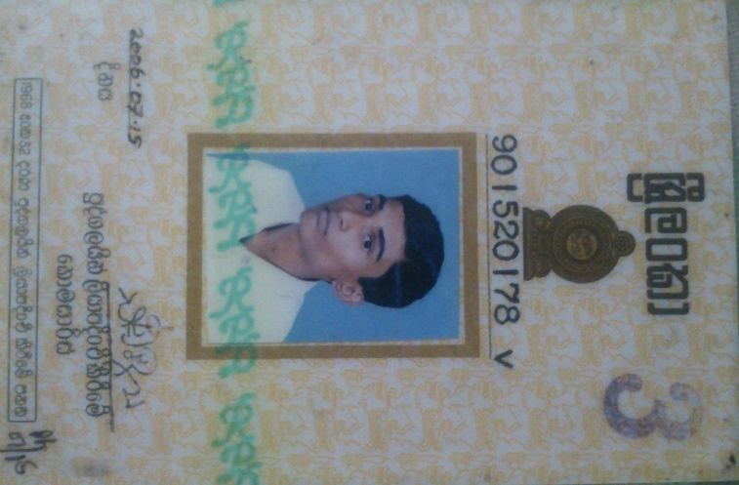 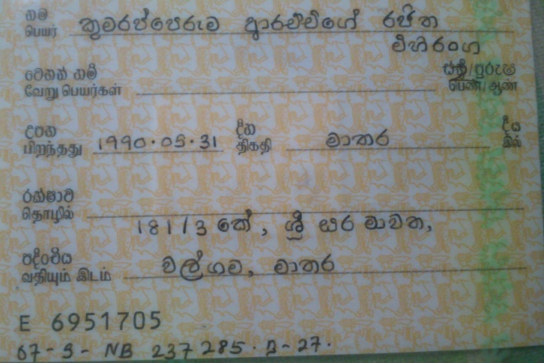

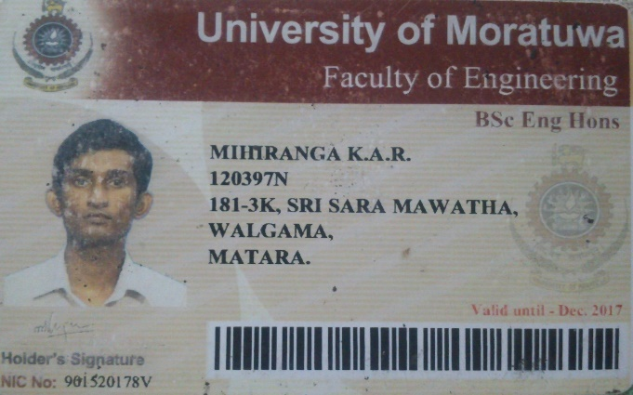 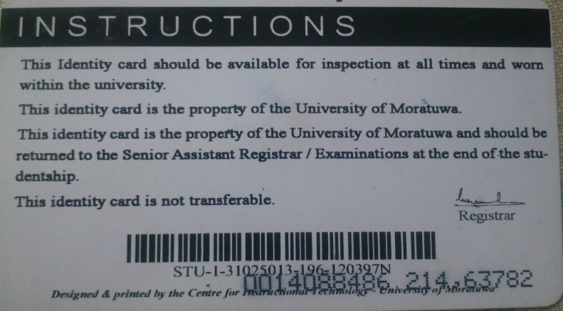

**Name** : Kumarapperuma Arachchige Rajitha Mihiranga

**Address** : 181/3 K , Sri Sara Mawatha , Walgama , Matara.

**NIC** : 901520178v

**Contact NO** : 0719333595

**Package** : 9 GB

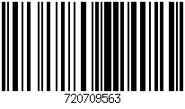

8994032300714381920